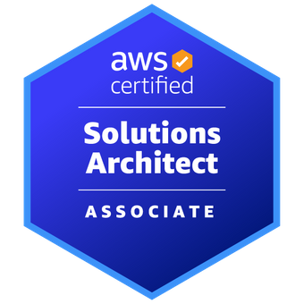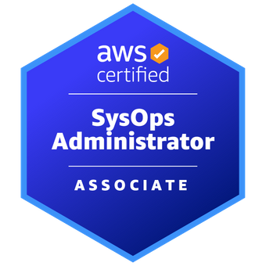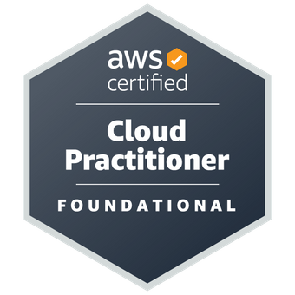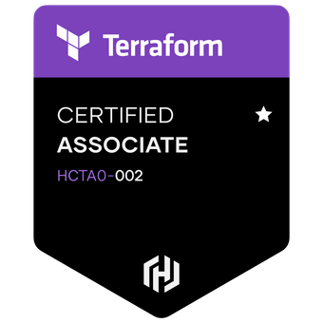

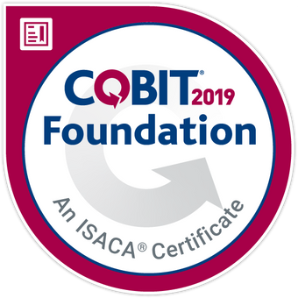

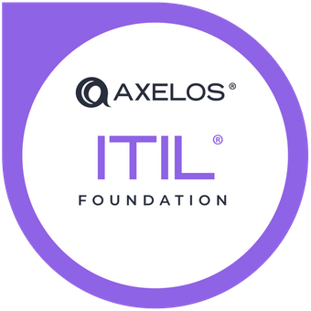



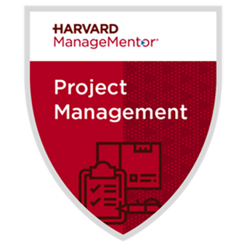

I am a self-motivated, highly enthusiastic professional having 13+ years of experience in IT industry spanned across – BFSI, Aviation, Energy & Transportation domains.

I worked as a Technical Cloud Solutions Architect, Cloud Project Lead. Currently working as a

Sr. Staff Cloud Engineer helping organizations to migrate and modernize their applications to cloud.

Rich experience of managing multiple technology stacks and teams distributed across onshore, offshore, and nearshore., with the head count of 17+ members.

Having expertise in Change Management, Release Management, Version Control & ITIL methodologies. Vast experience of working on the Hybrid cloud environment (OnPrem & Cloud), with the customers applications distributed across AWS, AZURE & OnPrem.

**Certifications:**

* ***Denodo® Administrator Certified***
* AWS Solution Architect – Associate ®
* AWS SysOps Administrator – Associate ®
* AWS Cloud Practitioner Certified®
* Terraform Certified Associate®
* Microsoft Certified: Azure Fundamentals®
* Microsoft Certified: Azure Data Fundamentals®
* Certified in Six - Sigma Green Belt
* Management Development Certificate
* Azure Databrick Certified
* Certified Scrum Master®
* Certified in PRINCE2® Foundation
* Certified in ITIL V3® Foundation
* Certified in COBIT® Foundation
* Project Management for Beginners (PMI)
* Project Management Harvard Manage Mentor

**Skills & Technologies:**

|  |  |
| --- | --- |
| **Primary Skills** | AWS Cloud, Terraform, Shell Scripting |
| **Other Soft Skills** | Stakeholder Management, Customer Obsession, Humility |
| **Cloud Stacks** | AWS VPC, S3, AWS EC3, AWS Cloud Watch, AWS EFS, EBS AWS RDS, Cloud Formation, ELB, IAM, KMS, Autoscaling, Lambda, Elastic Beanstalk |
| **DW/BI Tools** | Informatica, IICS, Denodo, DataIku, Appworx, ATACCAMA, DataFlux, Power Exchange CDC, ILM, MetaData Manager, CrushFTP, OpenVPN |
| **OS** | Linux, Unix & Windows Administration |
| **DevOps** | uDeploy, Jenkins, SVN, GITHUB, NewRelic, Splunk |
| **Scripting** | Unix Shell Scripting |
| **Databases** | PostGreSQL, MYSQL, Oracle |
| **Change Management** | Service-Now, JIRA, Confluence, Rally |

**Work Experience:**

# Sr. Staff Cloud Engineer | Nov 2022 to Till Date | ZT Systems, TN (USA)

* Orchestrated AWS System Manager for EC2 Patching, Compliance Reporting for 300+ EC2 instances
* Did OpenVPN Setup to ensure 1500+ users to securely access organizations resources and applications.
* Resized and compute optimized 120+ AWS Instances to optimize the AWS Infrastructure Cost 50K USD.
* Orchestrated AWS Workspace deployment for 2000+ users
* Implemented MFA logins for 2000+ users for AWS services and Instances using the DUO, OKTA
* Deployed Palo Next Gen VM Series Firewalls to Protect the AWS Resources and 350+ applications
* Orchestrated the SMTP servers leveraging the AWS SES & DUO Proxy Server Setup

# Senior Principal Consultant | April 2022 to Nov 2022 | Genpact LLC. TN (USA)

* Architected and deployed 50+ the highly scalable applications on the AWS cloud via Terraform
* Setting up the 10+ VPCs, 30+ Private/Public subnets, NAT, Bastion Host, 50+ S3 Buckets &RDS dbs.
* Did security setup using SG Groups, NACLs, WAF, KMS, SSL to secure data transfer for 25+ vendors
* Orchestrated observability via DataDog(NewRelic), CloudWatch to monitor 200+ Apps & machines
* Deployed Zscaler ZPA, ZIA & ZCC on AWS cloud to secure & support 100+ apps and 3000+ IT users

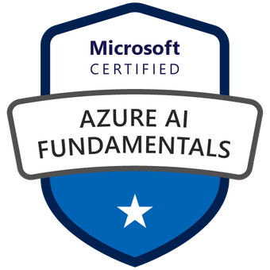

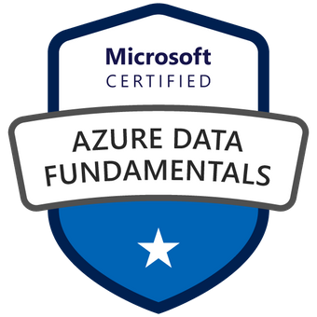

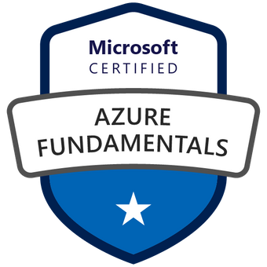

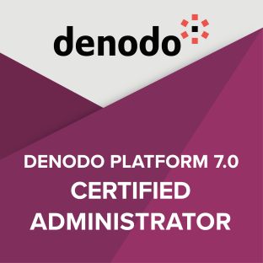

# Technical Solutions Architect | May 2021 to April 2022 | Tech Mahindra, TN (USA)

* Did a Lift & Shift of applications simultaneously for 3+ business to migrate apps to AWS Cloud
* Deployed multi-account (5+) AWS environment using the Control Tower/Landing-Zone
* Orchestrated the IAC using the Terraform & CloudFormation, deployed 50+ apps on AWS Cloud
* Orchestrated the Cloud DWH pipelines via various databases PostGreSQL, Snowflake, AWS RDS
* Did set up for LDAP, SSO, SAML, Private Link for 3 trier applications on cloud

# Cloud Project Lead | Aug 2014 to May 2021 | Tech Mahindra, TN (USA)

* Led the cloud migration and transformation of 18+ BI & Data Analytics tools
* Orchestrated OnPrem CI/CD pipeline using uDeploy ➜ Jenkins ➜ GitHub (SVN) for 20+ projects and apps
* Built cloud-native CI/CD pipeline via CodePipeline ➜ CodeBuild ➜ CodeCommit ➜ CodeDeploy
* Did setup the logging & SRE using ▲ VPC Logs ▲ Splunk ▲ CloudTrail with approx. log size of 1.2 TB
* Orchestrated 270+ workload automation & Job Scheduling via Appworx ▲ AWS Batch ▲ Event Bridge

# Platform Architect | Mar 2013 to Aug 2014 | Tech Mahindra Ltd

# Offshore Team Lead | Jan 2011 to Mar 2013 | Tech Mahindra Ltd

# Software Engineer | December 2009 to Jan 2011 | Tech Mahindra Ltd

**Educational Qualifications:**

|  |  |  |  |
| --- | --- | --- | --- |
| **Degree** | **Specialization** | **University** | **Year** |
| Master’s | Master of Technology | Birla Institute of Technology & Science | 2016 |
| Bachelor | Bachelor of Computer Applications | Karnataka University | 2009 |